Indent Value Increase Request Manual

- Buyer will get an error message on send for approval when PO amount is more than Indent amount and PO is in created state.

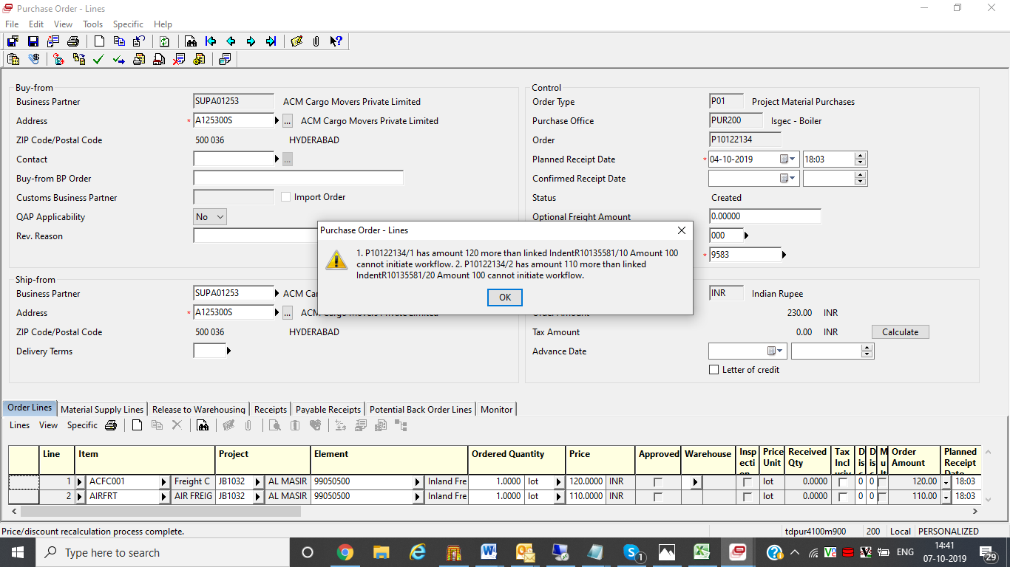

- Generate Request for Indent approval
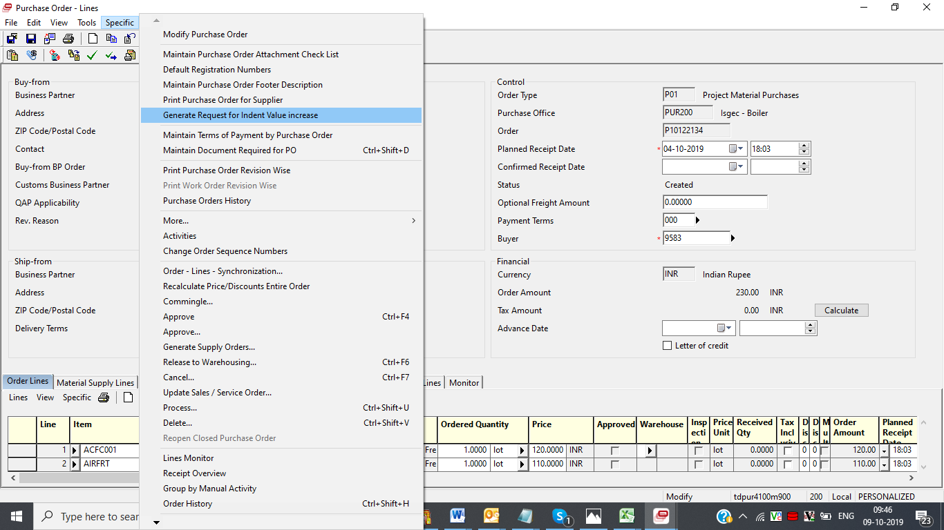

- Send Request for approval to Projects Dept.
  - An email alert will go to Indenter and Project managers of the project mentioned in Requisition
  - If value of PO is changed after generation of request then Update Request Button will update the request with changed amount
  - If request is generated but buyer does not want to execute it further then request has to be cancelled using Cancel Request button.
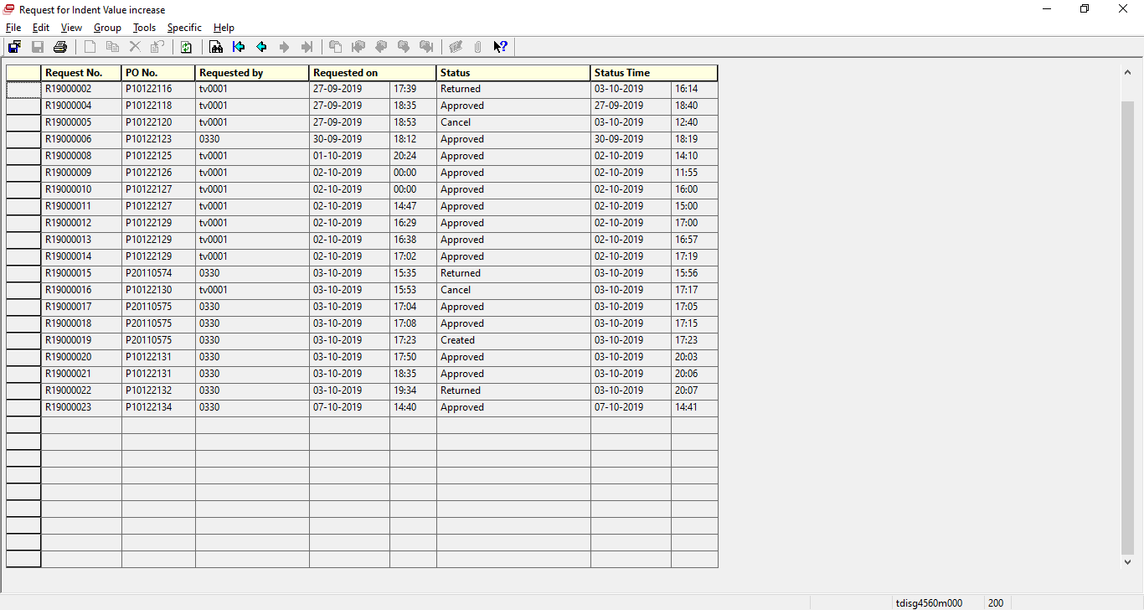
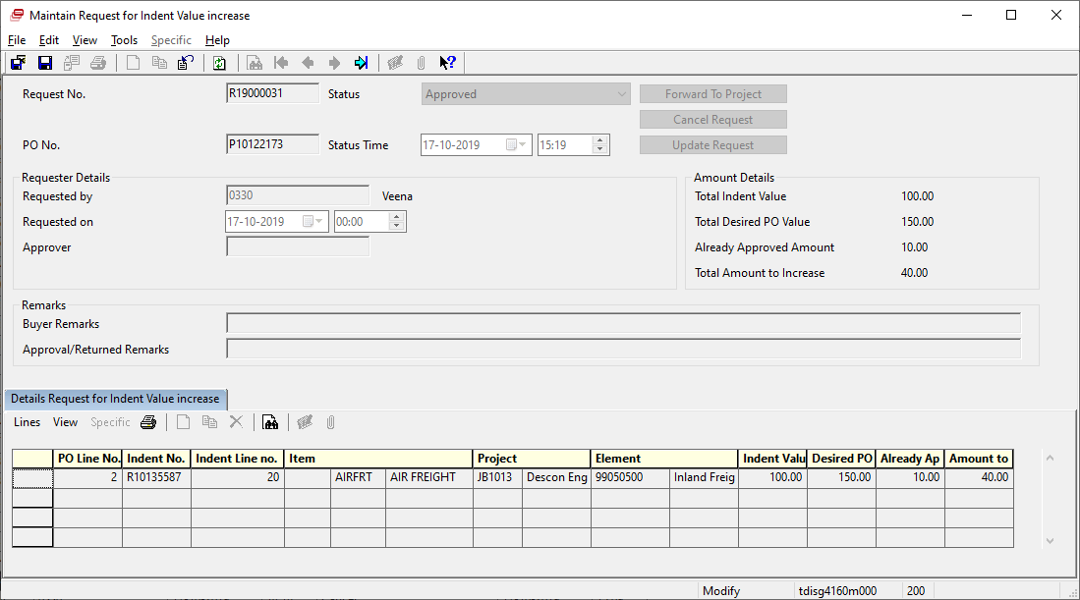
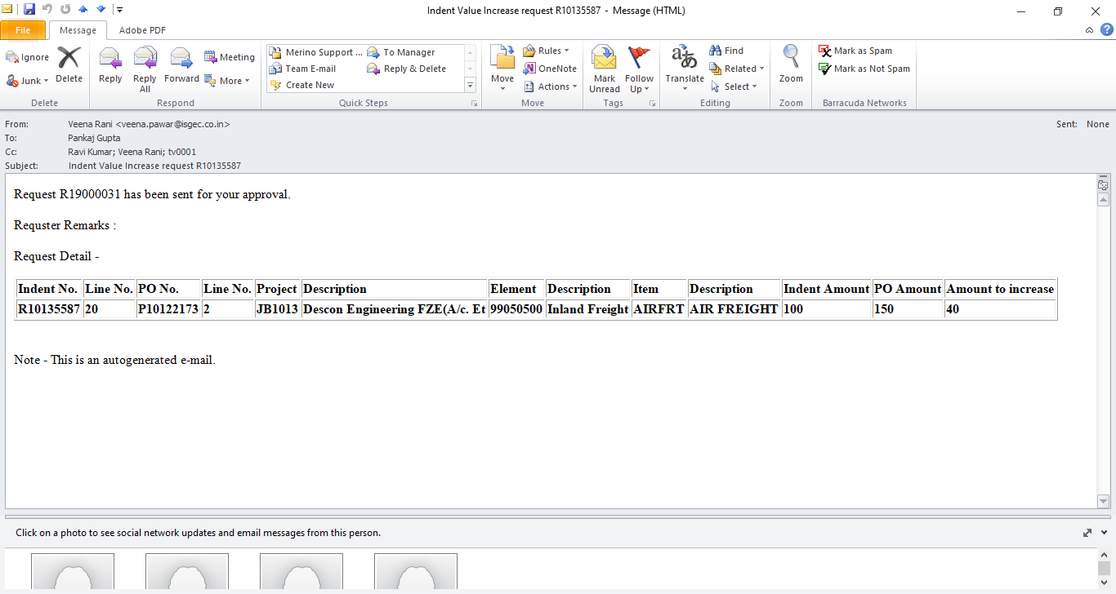

- Approval of Request by Projects :
  - Project managers who have sanction control role matrix of project can approve the request .
  - Project Manager can approve or reject request.
  - In both cases an email alert will go to buyer.
  - On approval of request soft allocation of corresponding Project/Element will increase.
  - Request can be approved only when sufficient balance for PO is available in element
  - On Return sanction control will not impact.
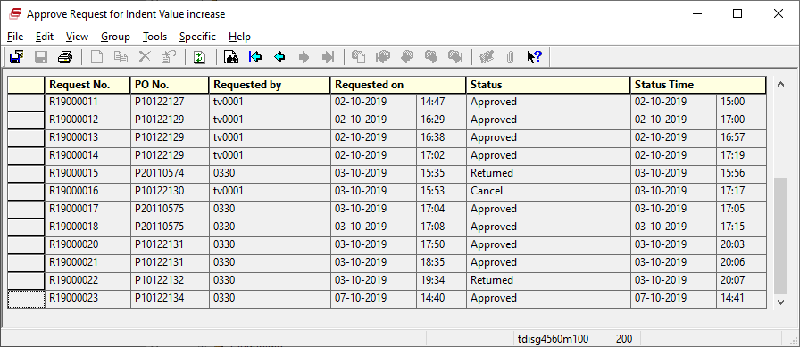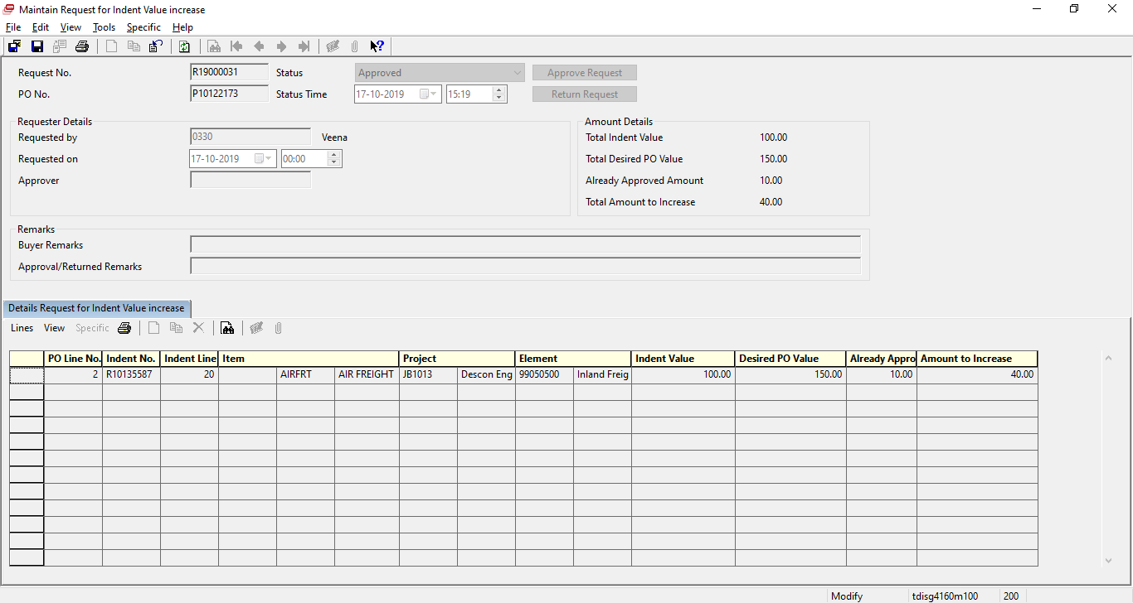
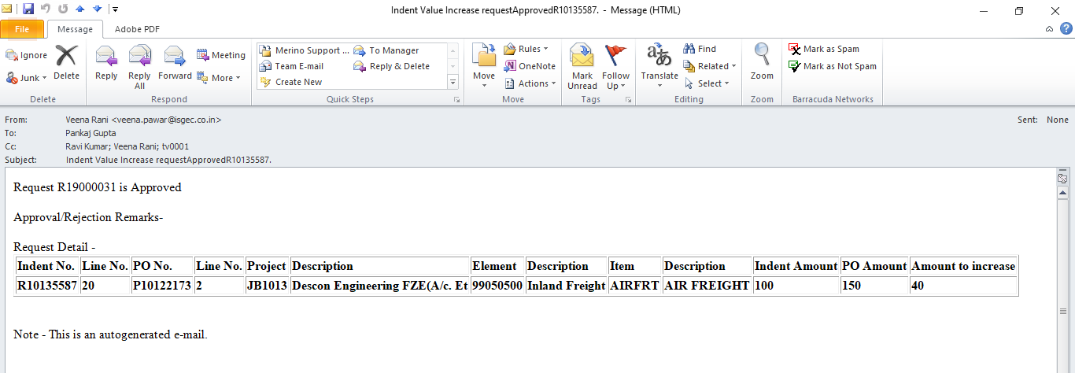

- Sanction control soft allocation is updated
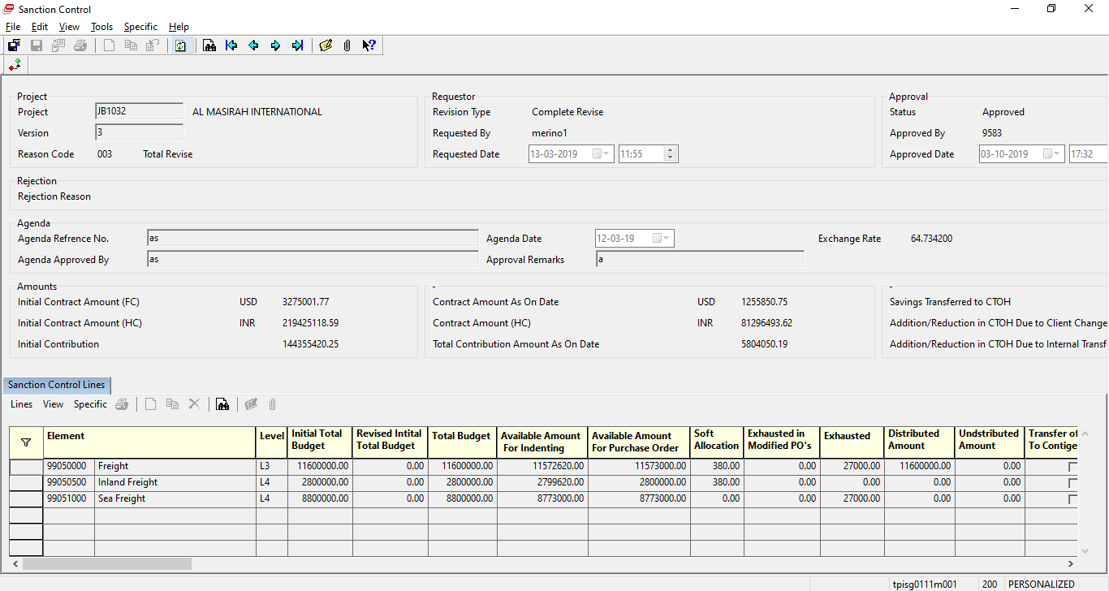

- History of Request is logged in system
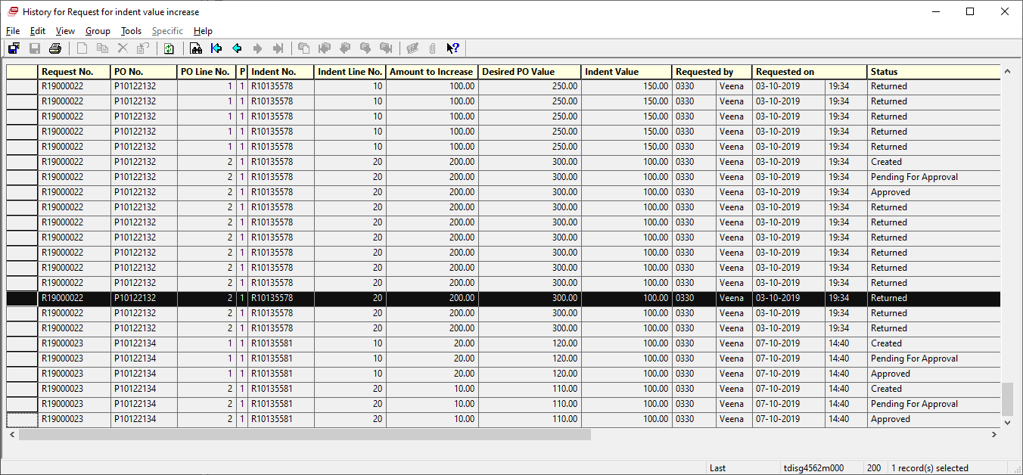

- Report for excel output of Request data is available

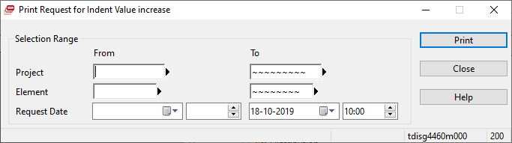

**End of Document**

